AcumenInvoice
Intelligent Invoice Processing — Built for Control and Confidence

In every dealership, distributor, and parts operation, the AP desk faces the same quiet crisis: stacks of vendor invoices, each one a small puzzle of line items, taxes, freight charges, and approval signatures. Mistakes are expensive. Delays are worse. And handing your financial documents to a cloud-based AI service feels, for many businesses, like handing a stranger the keys to the vault.
AcumenInvoice was built to solve that problem — completely, securely, and on your terms.
01 Multi-Layer Cross-Validation — 97%+ Recognition Accuracy
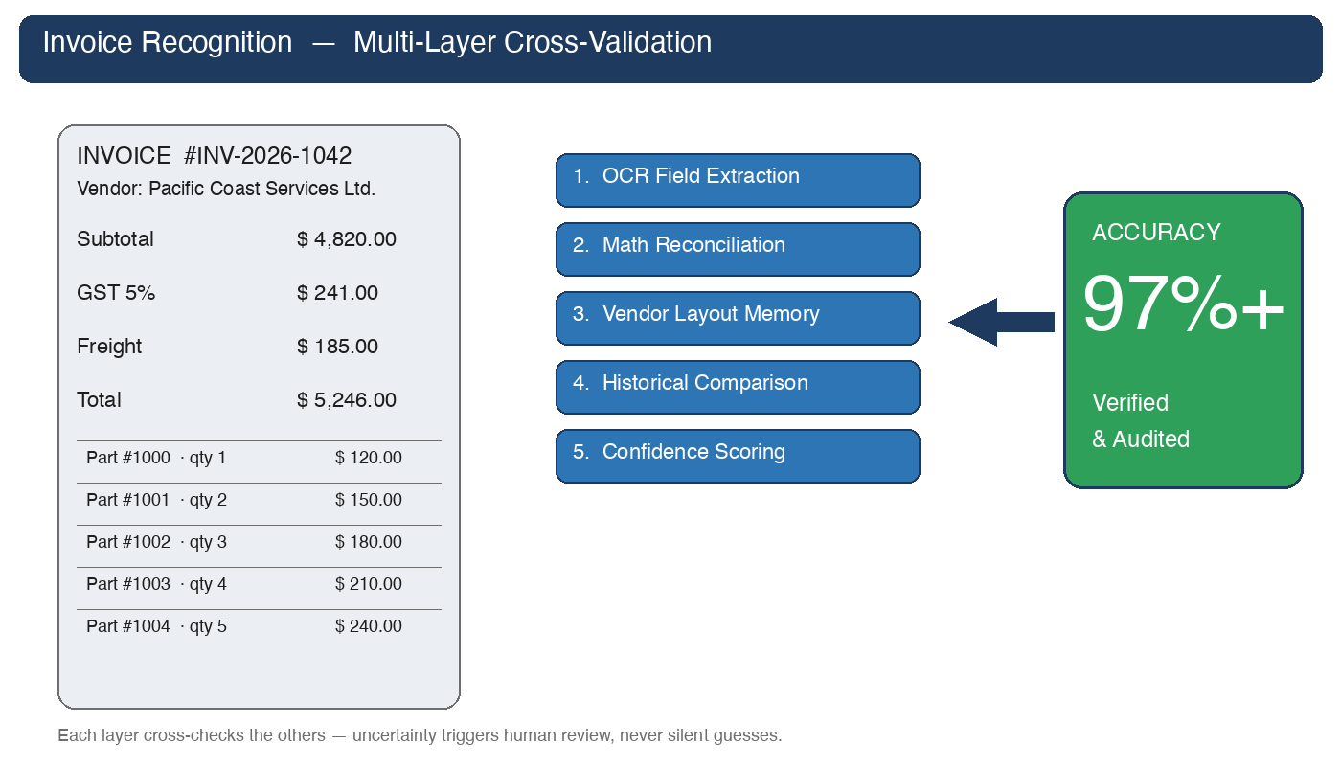
A single OCR pass is never enough. Real invoices arrive crumpled, scanned at angles, faxed in low resolution, or generated by vendor systems with idiosyncratic layouts. AcumenInvoice combines multiple recognition and validation strategies that check each other's work.
- Structured field extraction: invoice number, vendor, date, PO reference, line items, subtotal, tax, freight, grand total.
- Mathematical reconciliation: lines must sum to subtotal; subtotal + tax + freight must equal printed total.
- Vendor-specific layout learning remembers each supplier's quirks.
- Historical comparison surfaces anomalies in pricing, quantity, or formatting per vendor.
The result is sustained recognition accuracy above 97% on real-world traffic — and a system that knows when it is uncertain and asks for human confirmation rather than silently guessing.

02 Flexible Approval Workflows You Define
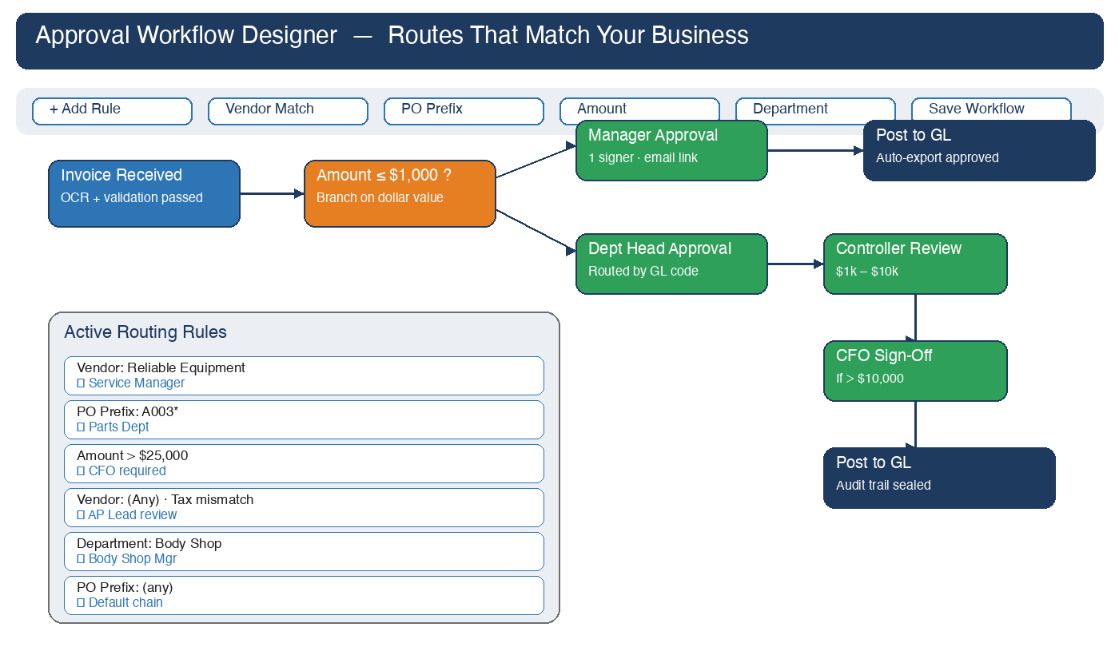
No two organizations approve invoices the same way. A small parts order might need only a manager's nod; a five-figure capital purchase might need three signatures and a CFO sign-off. AcumenInvoice's fully configurable routing engine adapts to how your business actually works.
- Rule-based routing by vendor, PO prefix, dollar amount, department, or GL code — including catch-all 'Any' rules.
- Multi-step approval chains with conditional branches, parallel approvers, escalation timeouts, and delegation.
- Email-link approvals so reviewers approve from their inbox — protected by single-use tokens with a complete immutable audit log.
- Visual rule builder lets finance leads adjust workflows themselves, without filing an IT ticket.

03 Customer Customization & Fast Service
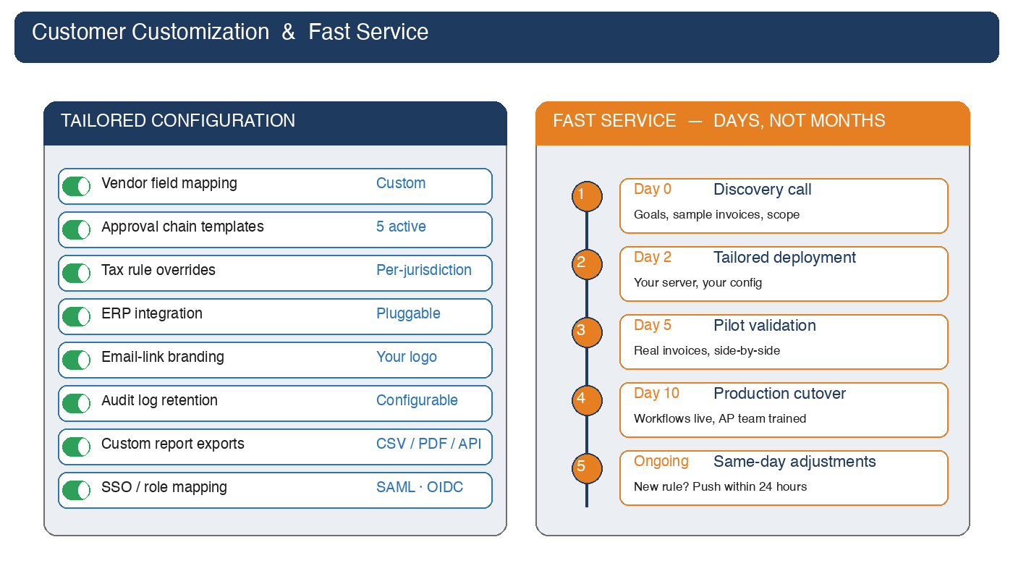
Most AP automation projects stall in six-month customization cycles, leaving finance teams stuck in spreadsheets while the vendor's professional services team works through their backlog. AcumenInvoice takes the opposite approach: build alongside you, ship in days, iterate continuously after launch.
- Custom field mappings, approval templates, tax overrides, ERP connectors, and report exports — all part of standard onboarding.
- Production cutover in days, not months — typical timeline is 10 days from kickoff to going live.
- Same-day rule changes after launch: new vendor, new routing path, new GL coding pushed within 24 hours.
- Branded email-link approvals carrying your logo and colors — your AP team sends from your brand, not ours.
- Direct line to engineering during onboarding — no ticket-queue purgatory.
The cost of slow service is not measured in support tickets — it is measured in months of automation deferred. We make sure that cost is yours to capture, not ours to bill.

04 100% On-Premise — Your Data Never Leaves Your Building
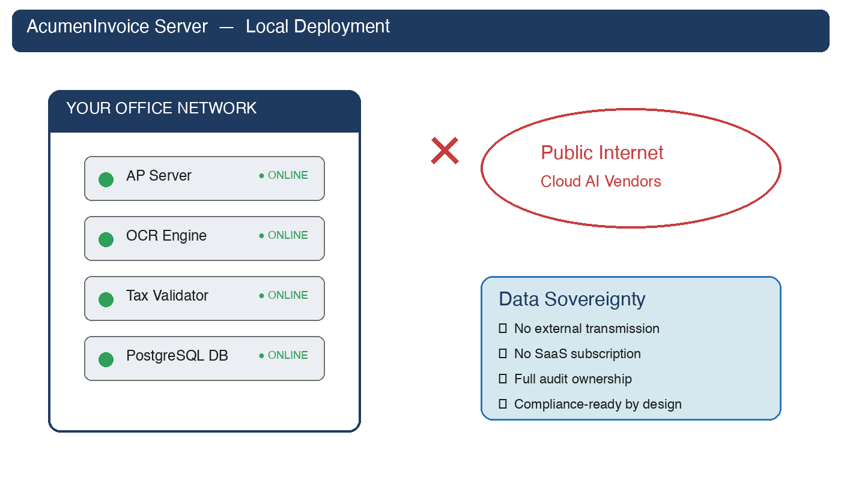
AcumenInvoice runs entirely on your own server, inside your own network. There is no cloud subscription, no third-party data processor, no hidden telemetry, and no invoice image, vendor name, or tax ID is ever transmitted to an external service unless you explicitly choose to integrate one.
- All processing — OCR, parsing, validation, routing, storage — happens on hardware you control.
- Vendor pricing, margin data, and purchasing patterns never leave your premises.
- Data-residency, IT-security, and audit obligations are satisfied by design, not by paperwork.
- No vendor lock-in: you own the database, the documents, and the deployment.

Ready to see AcumenInvoice in your own environment?
Contact us to schedule an on-site demonstration.

